HOW TO HOST A STATIC WEBPAGE IN S3

CREATE AN S3 BUCKET

* Log in to AWS Console and go to S3.
* Click Create bucket.
* Uncheck "Block all public access" (for public websites).
* Click Create bucket.

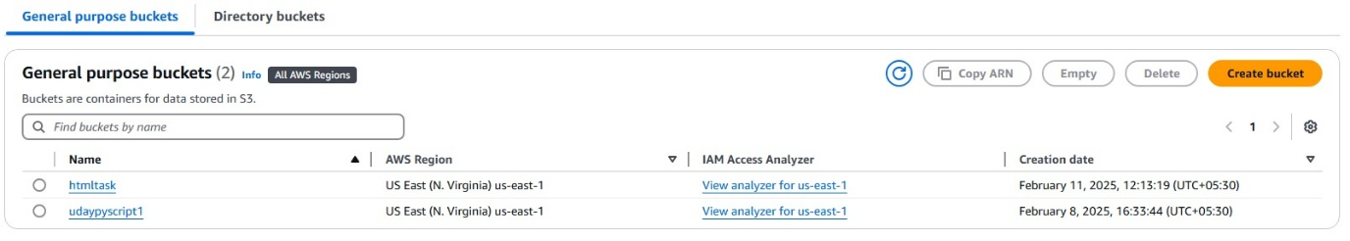

UPLOAD YOUR WEBSITE FILES

* Go to the Objects tab.
* Click Upload and add your index.html & Click Upload.

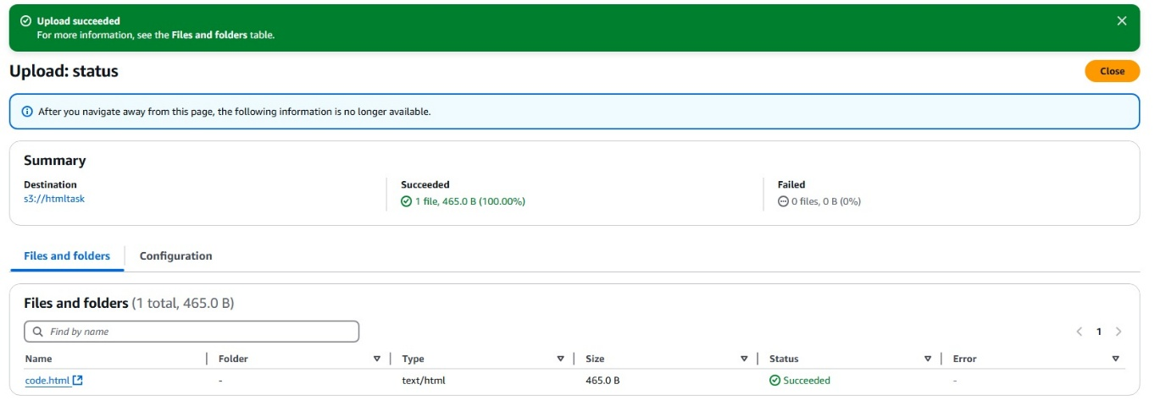

ENABLE STATIC WEBSITE HOSTING

* Go to the Properties tab.
* Select Static website hosting and enable.

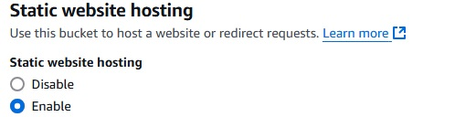

MAKE FILES PUBLIC & ACCESS YOUR WEBSITE

* Go to the Permissions tab. Uncheck block public access and ACL enable in object ownership.
* Copy the Bucket URL & Open it in your browser.

